Case Study: Sierra Leone
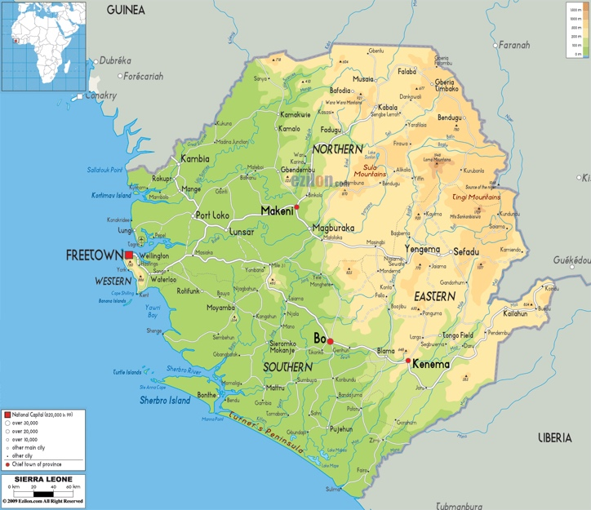
It is strongly recommended that participants use their own case study from their context of work. This case study is provided as a backup. This scenario is informed by multiple sources, including: INEE Guidance Note on Conflict Sensitive Education; Novelli, M. (2011) The Role of Education in Peacebuilding: Case Study Sierra Leone. New York: UNICEF; and the sources indicated below.

Background
Sierra Leone is located in West Africa, a region that has faced multiple conflicts. Recent conflict in Sierra Leone began in the East (region with highest poverty levels) and was triggered in 1991 with an insurgent movement of the Revolutionary United Front to overthrow the ruling All People’s Congress (in power since 1968). The insurgent movement was motivated by unequal access to economic markets and government services, including education. The war was fought by a combination of state, civil defence forces and UN troops. The conflict is infamous for the use of child soldiers, amputations and rape as a weapon of war. The 10-year war in Sierra Leone officially ended in January 2002. (Map source: http://www.vidiani.com/?p=9787)

Education and Conflict
Lack of access to secondary education and the lack of employment following graduation from secondary school are among the considered causes of the conflict. The collapse of the education system prior and during the conflict resulted in school closures, absent teachers, lack of payment of teachers, widespread strikes and generalized instability. It also correlated with the forced or voluntary recruitment of angry, unsatisfied, educated and uneducated youth population into armed groups. By the war’s end the majority of schools, including those in Freetown, were either non-usable or required reconstruction/refurbishment. Thousands of teachers and students were killed, maimed, displaced and recruited into warring factions.

Education and Peacebuilding
Post war, the 2007 UN Peacebuilding Cooperation Framework and the 2009 Joint Vision for the Sierra Leone prioritized security, democracy and markets, rather than wider social transformation and education. The Education Sector Plan and the Peacebuilding Strategy were developed separately; a trend that has continued through subsequent plans. Truth and reconciliation programmes focused on the national level and granted blanket amnesty to the majority of perpetrators. Several NGOs and the Ministry of Education have implemented education interventions parallel to, but not integrated in, UN and international peacebuilding efforts.

Current Education
A decade after the end of the war, the Education Sector Plan is comprehensive, systems-focused and underfunded with few conflict sensitivity provisions to target the inequity in supply. 50% of education funding is external. Education policy promises free and compulsory schooling up to grade 9 but a shortage of teachers and schools makes universal access impossible, especially for the 62% of the population residing in rural areas. Continuing the inequity that occurred during the British colonial era, education supply is biased towards higher education and the urban, Western region. Teacher training is scattered, sporadic and short-term and remuneration systems are tardy with little incentives for rural hardship posts. Many schools are small and in remote locations making teacher deployment sensitive and difficult. Hidden costs of education are barriers for many in a country where 70% of the population is below the poverty line of 2USD/day and over half of the working population is living off of subsistence agriculture.
(Chart source: http://www.audiencescapes.org/country-profiles/sierra-leone/communication-habits-demographic-group/provinces/provinces-315)
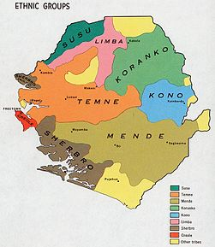
Current Socio-cultural Context
While the population of Sierra Leone comprises about 16 ethnic groups, each with its own language and custom, English is the language of instruction in schools and government administration; the majority population speaks Krio. Commonly held values and attitudes include: respect for elders and chiefs, mistrust of unemployed and idle youth, importance of education for children, freedom of religious practice (Islam, Christian, and Indigenous), appreciation of higher classes and titles, allegiance to tribes, importance of village community and dialogue, and belonging to gender-specific secret associations. (See mapping of ethnic groups dated 1969. Map source: http://commons.wikimedia.org/wiki/Atlas_of_Sierra_Leone)

Economic Context
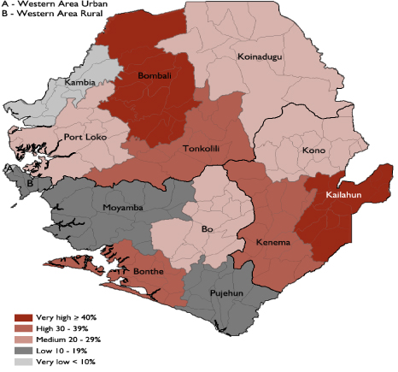
Sierra Leone is one of the lowest ranked countries on the Human Development Index. Economic and social development is highly uneven, with wide disparity between Freetown/Western Area, and the rest of the country (see map of poverty levels). Rural-urban inequalities and widespread poverty persist. While it possesses substantial mineral, agricultural, and fishery resources, economic development remains challenged by the limited infrastructure. Diamond mining is the major source of earnings. Nearly half of the working-age population engages in subsistence agriculture. A high number of unemployed, unskilled and illiterate youth resulted from the 70% of the school age population that missed out on education during the decade of war. Underlying tensions between the marginalized youth, including former combatants and the larger political, economic and social systems has persisted. (See map of levels of extreme poverty by district in Sierra Leone in 2003/2004. Source: Woldt et al., 2009)

Current Political Context
In the past few years, the country has navigated two elections without large-scale conflict. Administration of the state is burdened by a legacy of post-colonial mismanagement and corruption. The national army is the Republic of Sierra Leone Armed Forces (RSLAF), which took over responsibility for security from the UN in 2005. There are 3 provinces and the Western Area. Independence day is April 27. The four main political parties are: All People's Congress or APC, Peace and Liberation Party or PLP, People's Movement for Democratic Change or PMDC, Sierra Leone People's Party or SLPP and others. International agency presence includes: International Monetary Fund, UNESCO, World Health Organization, International Labor Organization, International Federation of the Red Cross and many others.

Environment
The topography includes coastal lowlands in the West to mountains in the East. There is a rainy season (May to December), winter dry season (December to April).

Program Description
You work for a British non-governmental organization, Education is a Right, which is starting up a DFID-funded, five-year, GBP1 million, junior secondary education project in Sierra Leone. Through partnerships with local NGOs, the project is to be rolled out in phases across 5 rural districts (not yet selected) in the Eastern and Northern provinces. The program operational budget includes three offices, 10% expatriate salaries and 90% local salaries. Reports and communication with the head office and donors must be conducted in English. Once hired, the local staff will make the decisions on additional program parameters regarding: construction, teacher training, administration and prioritization of beneficiaries and districts. You want to help the team by identifying some conflict sensitive strategies to determining the program details.

