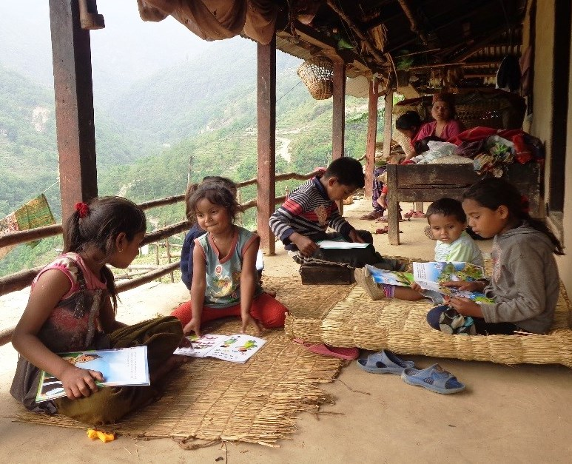

All Children Reading – Asia ­

Early Childhood Education:

Considerations for Programming

Sustainability

Sustainability of early childhood education requires objectives and strategies to ensure sound governance and adequate and reliable financing over the medium to long term.

PHOTO: On a Saturday afternoon, children from birethanti resource center read aloud stories from the supplemental reading materialsmaterials (USAID NEPAL)

## sustainability of early childhood education

Governance and financing of early childhood education (ECE) are complex, involving multiple actors, levels, objectives, and approaches, from general expansion of education access to targeted coverage of the most underserved. Coordination of actors and local community engagement in ECE are important dimensions in the governance and sustainability of ECE, above and beyond specific financing sources and arrangements. More than policies or systems alone, the quality and nature of governance is directly linked to a program’s chances for sustainability.

## ECE financing

To adequately fund the ECE sector, UNICEF proposes guidelines for governments of 1.0% of GDP (UNESCO, 2016) and the International Labour Organization (ILO) proposed a standard of 10% of total government expenditures (2014). The table below presents available recent data on countries’ government expenditures on ECE relative to GDP and to total government expenditure on education.

Government Expenditure on ECE and Percent of Enrollment in Private Institutions

|  |  |  |  |
| --- | --- | --- | --- |
| COUNTRY | Government expenditure on pre-primary education as % of GDP | Government expenditure on pre-primary education as % of total government education expenditure * | Percentage of pre-primary enrollment in nongovernment institutions (%) |
| Bangladesh | No data | No data | 41.8% |
| Cambodia | 0.05% | 2.6% | 14.7% |
| India | 0.06% | 1.5% | 75.4% |
| Indonesia | 0.06% | 1.7% | 94.6% |
| Kyrgyz Republic | 0.59% | 10.5% | 3.2% |
| Lao PDR | 0.19% | 6.5% | 18.0% |
| Nepal | 0.08% | 2.1% | 36.1% |
| Philippines | No data | No data | 18.0% |
| Tajikistan | 0.28% | 5.3% | No data |
| Vietnam | 0.89% | 15.3% | 12.8% |

Recommendations

|  |  |
| --- | --- |
| Analysis | Recommendations |
| The degree of government spending on ECE does not always translate into progressive provision or sound stewardship. Countries with more modest levels of government spending on ECE may still practice progressive programming. | Both government and nongovernment financing through block grants, conditional cash transfers, and community-based approaches have been applied in limited but promising efforts to orient resources in a progressive manner. |

## ece governance

Effective governance is key in ECE work, particularly since multiple actors are often involved, including multiple ministries (education, health, family, women and children, social services, etc.) and a wide range of providers, from home-based and community operations to NGOs, public and private sector establishments, and places of work (UNESCO, 2016).

Delivering quality ECE to more and more children demands the following:

* Sound decisions relating to standards, objectives, and programs that are both technically and contextually appropriate
* Effective oversight of the observance of standards, with appropriate follow-through
* Planned and careful coordination of the resources and actions of the range of actors and stakeholders

The following table presents the various governance structures that are in involved in the decision making and oversight of ECE in the respective countries.

Governance Structures That Oversee ECE Decisions

|  |  |
| --- | --- |
| Country | Governance Structure for ECE |
| Bangladesh | Ministry of Primary and Mass Education  Ministry of Women and Children Affairs  Other key ministries involved include the Ministry of Health and Family Welfare and the Ministry of Social Welfare. |
| Cambodia | Ministry of Education, Youth and Sport oversees the National Committee for Early Childhood Care and Development, which consists of 14 cross-cutting ministries. |
| India | Ministry of Women and Child Development in collaboration with Ministry of Health and Family Welfare, Ministry of Human Resource Development, and Ministry of Social Justice and Empowerment |
| Indonesia | The National Development Planning Agency coordinates planning across all ministries on early childhood development (ECD), developing national strategies and a national development plan.  The Coordinating Ministry for Human Development and Culture coordinates ECD programs across sectoral ministries.  The Ministry of Education and Culture and Ministry of Religious Affairs govern operation of ECE establishments. |
| Kyrgyzstan | Ministry of Education and Science Department of School, Preschool and Extracurricular Education  Department of Maternity and Childhood within the Ministry of Health  Department of Child Protection within the Ministry of Social Development |
| Lao PDR | Ministry of Education with Ministry of Health |
| Nepal | Ministry of Education (Department of Education) in collaboration with Ministry of Health; Ministry of Women, Children, and Social Welfare; and Ministry of Federal Affairs and Local Development |
| Philippines | The Early Childhood Care and Development Council for the Welfare of Children under Office of the President oversees implementation of national ECD system.  The Department of Education governs ECE specifically. The Department of Social Welfare and Development governs protection of citizens’ social welfare and rights and promotion of social development. The Department of Health and the Union of Local Authorities of Philippine National Nutrition Council are also involved. |
| Tajikistan | Ministry of Education, with additional ECD services provided through Ministry of Health and Ministry of Labor and Social Protection  Ministry of Finance |
| Vietnam | Ministry of Labour, Invalids and Social Affairs oversees the coordination of ECD programs across ministries.  Other ministries implementing ECD include Ministry of Education and Training; Ministry of Health; Committee for Population, Family and Children responsible for overall child-focused policy; and the Viet Nam Women’s Union, which is responsible for parent education. |

Sources: ARNEC (2018) country profiles for Bangladesh, Cambodia, India, Indonesia, Nepal, Lao PDR, Philippines, and Vietnam; Jung & Hasan (2016) for Indonesia; SABER (2013c) for Tajikistan

Beyond national government structures, as we have noted, other active providers and stakeholders include NGOs, private foundations and faith-based institutions, international agencies, local government, and communities.

### Coordination across national government structures

Implementing multisectoral policy and managing a plurality of both government and nongovernment actors call for effective mechanisms of coordination.

* Countries may opt to identify a specific ministry to take on coordination of actions for a given age group.
* Countries may establish cross-ministerial coordinating committees or task forces, as is the case in Bangladesh (Loizillon & Leclercq, 2016), Indonesia (Tan, 2016), and Vietnam (Asia-Pacific Regional Network for Early Childhood [ARNEC] web-based profile).
* Countries that have set up inter-ministerial committees, councils, or task forces on ECD include Cambodia, Nepal, and the Philippines (Loizillon & Leclercq, 2016; ARNEC web-based country profiles).

Effective coordination across ministries can be difficult, however, as shown in Kyrgyzstan (The World Bank Systems Approach for Better Education Results [SABER], 2013a), Lao PDR (Britto et al., 2013), and Tajikistan (SABER, 2013c).

### Coordination and collaboration with and between international agencies, NGOs, and the private sector

ECE in many countries is substantially, and in some cases predominantly, funded and supported by nongovernment actors. India and Indonesia have very high proportions of nongovernment sector participation in the provision of ECE programming, followed by Bangladesh and Nepal.

With such a range of actors, opportunities for innovation as well as exploitation call for effective governance, oversight, and coordination. For example, the Bangladesh ECD Network brought together government and NGO actors (including BRAC, Save the Children, Plan) to help develop and push for ECE policies; other key players include USAID, Bernard Van Leer Foundation, UNICEF, UNESCO, and The World Bank (Graham, 2017).

### Subnational and particularly local engagement

The relationship of ECE to its surrounding community is ideally a close one, as such programs strive to help children and families negotiate the social and cultural shift from the home to the school setting. In terms of governance, a strong local role in selecting and implementing approaches, and local accountability, can help ensure that a program will be responsive to the local context and increase its chances for sustainability over the longer term. Several of the focus countries for this report offer promising cases of local governance of ECE, such as Bangladesh’s School Learning Improvement Plan (Graham, 2016) and Cambodia’s national task force for early childhood (Britto et al., 2013).

Depending on the country, subnational states, provinces, and districts may have more or less mandated authority over ECE programming, oversight, and financing. Compared to national and community levels, intermediate levels of government, analysts often point out, are relatively weak in exercising much authority or effectively supporting implementation or coordination (Britto et al., 2013; Loizillon & Leclercq 2016; SABER 2013a, 2013b, 2013c).

Analysis and Recommendations

|  |  |
| --- | --- |
| Analysis | Recommendations |
| Countries vary considerably in the proportion of enrolled students who attend nongovernment pre-primary schools This proportion is an indicator that offers a rough though imperfect proxy for private, NGO, and household contributions to ECE provision, which, if high, might be expected to justify or balance relatively low government expenditure. | Government is not the only important source of financing that must be considered. These relatively more available proxy indicators can mask potentially high household contributions even for children attending public ECE schools. There is also the possibility that government systems may be funding private, NGO, and community schools. The utility of international (UNICEF and ILO) benchmarks to assess the adequacy of government financing will continue to be limited if availability of comparable data, including clearly disaggregated data on all sources of funding, across countries, is not improved, and unless other factors such as cost-efficiency (a concern for Kyrgyzstan) are also considered. |
| Countries vary regarding their implementation of coordination across government structures. | The degree to which a country invests in data systems to understand and manage the ECE sector across ministries can be indicative of government commitment to the sector as well as its capacity to manage and coordinate its services, and the sheer complexity of doing so given the plurality of sectors and actors. |
| For the most part, the countries under review in this paper have acknowledged the need for coordination, both through joint development of policy frameworks for ECE and in the establishment of committees or tasks forces, generally led by the ministry of education or its equivalent, to enable inter-ministerial and government–nongovernment coordination of ECE programming. However, the functionality and effectiveness of such mechanisms varies. | National-level networks that bring together government and nongovernment actors with international agencies and NGOs, and village- or commune-level efforts that promote and support the development and spread of local ECE solutions, may be more readily adaptable to a broader range of settings, as they depend less on well-established governmental hierarchical relationships to be introduced and maintained. |

## References

Asia Pacific Regional Network for Early Childhood (ARNEC). (2018a). *Bangladesh country profile*. Retrieved from <http://arnec.net/country/bangladesh->

ARNEC. (2018b). *Cambodia country profile*. Retrieved from <http://www.arnec.net/country/cambodia>

ARNEC. (2018c). *India country profile*. Retrieved from <http://arnec.net/country/india->

ARNEC. (2018d). *Indonesia country profile*. Retrieved from <http://arnec.net/country/indonesia->

ARNEC. (2018e). *Lao PDR country profile*. Retrieved from <http://arnec.net/country/lao-pdr>

ARNEC. (2018f). *Nepal country profile*. Retrieved from <http://arnec.net/country/nepal->

ARNEC. (2018g). *Philippines country profile*. Retrieved from <http://www.arnec.net/country/philippines->

ARNEC. (2018h). *Vietnam country profile*. Retrieved from <http://arnec.net/country/vietnam->

Britto, R.P., Yoshikawa, H., Van Ravens, J., Ponguta, L. A., Oh, S.S., Dimaya, R., Seder, R.C. (2013). *Understanding governance of early childhood development and education systems and services in low-income countries*. Innocenti/UNICEF Office of Research Working Paper No.2013-07, UNICEF Office of Research, Florence.

Graham, J. (2017). *Pre-primary education in Bangladesh: Participation has tripled but there’s a lot more work to do*. Retrieved from: https://apolitical.co/solution_article/unprecedented-rise-pre-primary-education-bangladesh/.

International Labour Organization (ILO). (2014). *ILO policy guidelines on the promotion of decent work for early childhood education personnel.* Geneva: ILO.

Jung, H. & Hasan, A. (2014). *The impact of early childhood education on early achievement gaps: Evidence from the Indonesia Early Childhood Education and Development (ECED) Project*. Washington, DC: The World Bank Policy Working PaperLoizillon, A., & Leclercq, F. (2016). *New horizons: A review of early childhood care and education in Asia and the Pacific*. Paris & Bangkok: UNESCO.

Systems Approach for Better Education Results (SABER). (2013a). *Kyrgyz republic early childhood development* (SABER Country Report). Washington, DC: The World Bank.

SABER. (2013b). *Nepal early childhood development* (SABER Country Report). Washington, DC: The World Bank.

SABER. (2013c). *Tajikistan early childhood development* (SABER Country Report). Washington, DC: The World Bank.

Tan, R.G.H. (2016). *Early childhood care and education in five Asian countries*. Singapore: The HEAD Foundation.

UNESCO. (2016). *Financing for early childhood care and education (ECCE): Investing in the foundation for lifelong learning and sustainable development*. Bangkok: UNESCO Bangkok.

## For further information, please contact:

## Mitch Kirby, USAID Asia Bureau, Senior Education Advisor, mkirby@usaid.gov