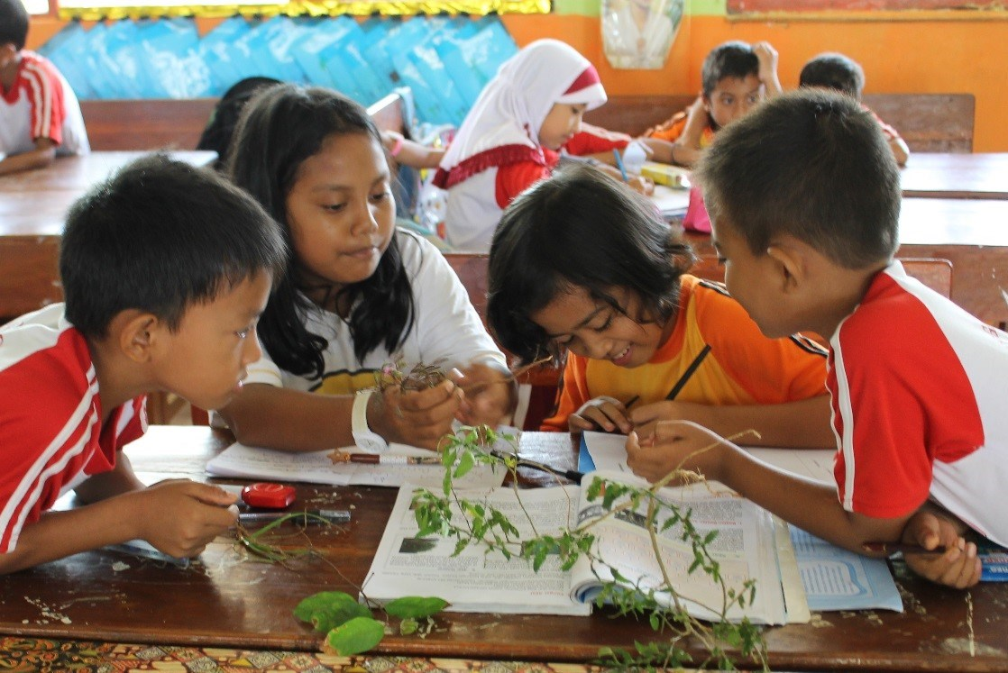

All Children Reading – Asia ­

Early Childhood Education:

Considerations for Programming

Early Childhood Educator Quality

PHOTO: Active Learning at SDN Wajo, SOuth SUlawest – USAID PRIORITAS projecT

Ensuring availability of educators with adequate training and motivation constitutes an important challenge for expansion and quality of early childhood education.

## current Quality guidelines and management for ECE teachers

Sun, Rao, and Pearson (2015) point out that the number of trained early childhood education (ECE) educators is, in many countries, grossly inadequate, especially in rural areas; these educators have lower qualifications, status, and wages than primary teachers. Training opportunities and appropriate teacher curriculum are often insufficient, and effective regulatory frameworks for preparing, staffing, and monitoring ECE teachers are often lacking. The table below presents selected country-by-country findings on policy relating to ECE teacher quality.

| **Country Policies Relating to ECE Teacher Quality** | |
| --- | --- |
| COUNTRY | Policies on ECE Teacher Quality |
| Bangladesh | Pre-primary education policy dictated the creation of national curriculum, teacher training materials, growth of assistant teacher positions.  Aspiring ECE teachers are formally required to have upper secondary education to be eligible to enter ECE teacher training, while the required qualification is higher for primary-level teachers (Sun, Rao, & Pearson, 2015). |
| Cambodia | Aspiring ECE teachers are formally required to hold an upper secondary degree to be eligible to enter training for service in state pre-schools. The same qualification is required for primary-level teachers (Sun, Rao, & Pearson, 2015). |
| Kyrgyzstan | State pre-school teachers are required to have 4-years of post-secondary education including pedagogical practice, and in-service training at least once every 5 years. Other types of programs have shorter requirements, according to the World Bank Systems Approach for Better Education Results (SABER) (SABER, 2013a). |
| Lao PDR | Aspiring ECE teachers are formally required to have some secondary or technical education to be eligible to enter ECE teacher training. The same qualification is required for primary-level teachers (Sun, Rao, & Pearson, 2015). |
| Nepal | National policy lays out standards for ECE teachers: Grade 9 or 10 or higher, as well as in-service training (SABER 2013b). |
| Philippines | ECE teachers are licensed only upon passing a licensure examination administered by the national-level Professional Regulation Commission (SEAMEO & UNESCO, 2016). |

## Southeast Asia Guidelines for Early Childhood Teacher Development and Management

The *Southeast Asia Guidelines for Early Childhood Teacher Development and Management* published by the South East Asian Ministers of Education Organization (SEAMEO) and UNESCO (2016) offer 22 core recommendations with explanations and examples to address issues of teachers' qualifications and standards, recruitment, education and continuous professional development, fair employment terms, and governance and funding. These guidelines were adopted by ministers of education from all SEAMEO countries in 2016. Development of an early childhood care and education (ECCE) teacher competency framework for Southeast Asia was supported by UNESCO as part of its work in pursuing Sustainable Development Goal 4.2, but the framework has not yet been endorsed formally by SEAMEO member countries (UNESCO & SEAMEO, 2018). The domains and core competencies of the framework can be seen in the table below.

|  |
| --- |
| **Domains and Core Competencies of the ECCE Teacher Competency Framework for Southeast Asia\*** |
| **Content knowledge, pedagogic practice, and assessment domain** |
| Core competency 1. Understands the child’s holistic development and learning. These are competencies related to ECCE teachers’ theoretical and practice-based knowledge and understanding of child development and learning.  Core competency 2. Facilitates child development and learning. These are competencies related to ECCE teachers’ strategies to facilitate child development and learning, including the use of assessment tools, techniques, and results to support child development and learning. | |
| **Learning environment domain** | |
| Core competency 3. Establishes a nurturing, inclusive, and safe environment. Includes competencies related to how teachers create environments conducive for children.  Core competency 4. Promotes health, nutrition, safety, and protection. Competencies related to strategies and practices to ensure that the child’s health, nutrition, safety, and protection needs are addressed. | |
| **Engagement and collaboration domain** | |
| Core competency 5. Engages parents and families as partners in ECCE. Competencies related to working with children’s families and caregivers as partners in ECCE.  Core competency 6: Networks and collaborates with relevant stakeholders to promote ECCE. Competencies related to working with a range of stakeholders concerned with the general wellbeing of children. | |
| **Professional development domain** | |
| Core competency 7. Ensures continuous personal growth and professional development. Competencies that demonstrate ECCE teachers’ commitment to improve themselves and the practice of their profession as ECCE practitioners. | |
| *UNESCO & SEAMEO, 2018 | |

Analysis and Recommendations

|  |  |
| --- | --- |
| Analysis | Recommendations |
| Policy frameworks vary widely by country, and implementation of these policies remains inconsistent. | Regional guidelines and frameworks such as the International Labour Organization (2014), SEAMEO and UNESCO (2016), and UNESCO and SEAMEO (2018) relating to ECE teacher development, management, skills, and competencies offer a basis on which to review and revise country-specific ECE teacher policies. Distance education and strengthened partnerships between government and non-state actors are promising avenues to improve the situation of the ECE workforce in terms of both quantity and quality (Sun, Rao, & Pearson, 2015). |

## In-service Teacher Training and support

ECE teachers are often inexperienced and come to the teaching profession without any formal training in teaching and how best to support students (Bold et al., 2017; Abuel-Ealer, 2012). As a result, in-service training and support is extremely important, as it may be the only training teachers will receive on how to teach learners. As more pre-primary programs are developed and implemented in these countries, teachers are beginning to receive more in-depth and extensive training and support.

Analysis and Recommendations

|  |  |
| --- | --- |
| Analysis | Recommendations |
| * In Bangladesh, teachers in one program received training when they first joined the program and a two-day training at the beginning of each year (Shahjamal & Nath, 2008). * Teachers in another program received a 5-day training at the beginning of the year, and a 4-day refresher training mid-year. The beginning of the year training focused on pre-mathematics, pre-literacy, and classroom management, while the mid-year training focused on curriculum, syllabus, and teaching techniques (Opel, Camellia, & Aboud, 2007). | Many programs found success offering both an initial training and refresher trainings to review content with teachers. This approach allowed new teachers to quickly become familiar with the content, as well as get continual reminders of both the overall approach and how to approach individual lessons in a given time period. |
| * In Bangladesh, teachers within two programs received a refresher training each month. This refresher training reviewed best practices and reviewed the lessons for the next month with the teachers (Shahjamal & Nath, 2008; Opel, Camellia, & Aboud, 2007). | Many programs offered monthly meetings to go over the month’s lessons with teachers in-depth, as well as to allow an opportunity for teachers to regularly discuss any issues they were having in the classroom. This helped teachers build a community of practice with fellow teachers, as well as feel prepared for their lessons for that month. |
| * In a reading intervention in Bangladesh, teachers were shown videos of teachers reading storybooks to children, using both a dialogic and traditional approach (Opel, Ameer, & Aboud, 2009). This helped teachers identify differences in both the way the story was read and the children’s responses. * Video was also used in training primary school teachers in Nepal, with trainers traveling out to rural areas with pre-taped training materials recorded on video. In addition to being more convenient for rural teachers, researchers found this also helped visual learners, aiding with memory, as videos could be watched more than once, and helped trainers become more confident as a result of filming and reviewing their training (Pouezevara & Parajuli, 2007). | Two programs found that video helped to supplement training. This was helpful as both a way to illustrate certain approaches (such as dialogic reading) and to allow rural teachers a way to receive regular training. |

## References

Abuel-Ealer, S. (2012). *Closing the trained teacher gap*. Global Campaigns for Education South Africa. Retrieved from: http://www.campaignforeducation.org/docs/reports/ECNAT%20Report_RGB.pdf

Bold, T., Filmer, D., Martin, G., Molina, E., Rockmore, C., Stacy, B., Svensonn, J., & Wane, W. (2017). *What do teachers know and do? Does it matter?* Retrieved from: https://elibrary.worldbank.org/doi/abs/10.1596/1813-9450-7956

Opel, A., Ameer, S. S., & Aboud, F. E. (2009). The effect of preschool dialogic reading on vocabulary among rural Bangladeshi children. *International Journal of Educational Research*, 48(1), 12-20.

Opel, A., Camellia, S., & Aboud, F. E. (2007). *Playing with mathematics: A pilot intervention to develop basic mathematical skills among preschoolers in Bangladesh*. BRAC University Institute of Education and Development, Dhaka, Bangladesh.

Pouezevara, S. L., & Parajuli, B. (2007). *Old technology or new? A study of video recording as an innovative method for primary school teacher training in rural Nepal.* Asian Development Bank. Retrieved from: http://citeseerx.ist.psu.edu/viewdoc/download?doi=10.1.1.546.7733&rep=rep1&type=pdf

SABER (2013a). *Kyrgyz republic early childhood development* (SABER Country Report). Washington, DC: The World Bank.

SABER (2013b). *Nepal early childhood development* (SABER Country Report). Washington, DC: The World Bank.

South East Asian Ministers of Education Organization (SEAMEO) & United Nations Educational, Scientific and Cultural Organization (UNESCO). (2016). Southeast Asian Guidelines for Early Childhood Teacher Development and Management. Bangkok: SEAMEO Secretariat and UNESCO.

Shahjamal, M. M., & Nath, S. R. (2008). An evaluation of BRAC pre-primary education program. Bangladesh: BRAC Centre.

Sun, J., Rao, N., & Pearson, E. (2015). Policies and strategies to enhance the quality of early childhood educators. (Background paper prepared for the Education for All Global Monitoring Report 2015, Education for All 2000-2015: achievements and challenges). Retrieved from: <http://unesdoc.unesco.org/images/0023/002324/232453e.pdf>

United Nations Educational, Scientific and Cultural Organization (UNESCO)& South East Asian Ministers of Education Organization (SEAMEO). (2018). *P*u*rsuing quality in early learning Vol. 1 / Early childhood care and education (ECCE) Teacher competency framework for Southeast Asia (SEA).* Paris & Bangkok: UNESCO & SEAMEO.

## For further information, please contact:

## Mitch Kirby, USAID Asia Bureau, Senior Education Advisor, mkirby@usaid.gov