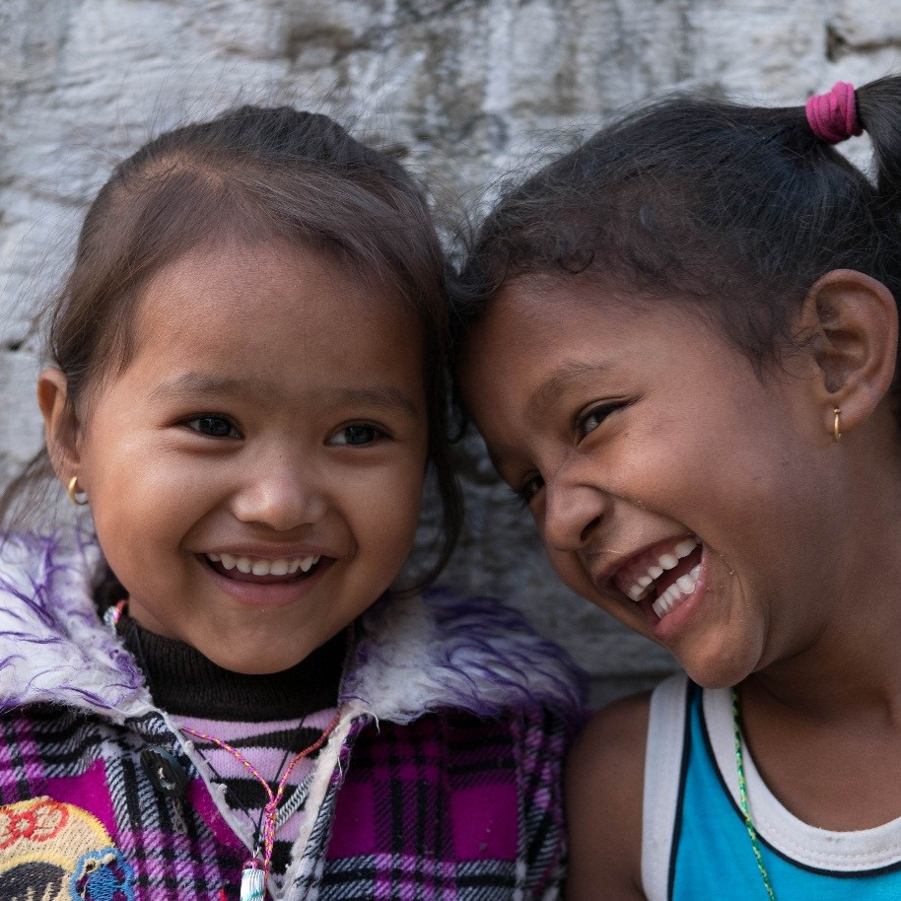

All Children Reading – Asia ­

Early Childhood Education:

Considerations for Programming

Overview

PHOTO: USAID NEPAL Health for life

Providing a quality education to children prior to primary school entry is crucial

## Importance of Early Childhood education globally

There is ample evidence of the importance of providing high-quality early childhood education (ECE).

* Longitudinal studies point to benefits such as higher secondary school graduation rates, less retention in lower grades, academic achievement throughout schooling, and high economic return on investment (Duncan et al., 2007; Elango, Garcia, Heckman, & Hojman, 2015; McCoy et al., 2017; Yoshikawa et al., 2013).
* The United Nations Sustainable Development Goal 4.2 calls for "all girls and boys to have access to quality early childhood development, care, and pre-primary education so that they are ready for primary education” (United Nations General Assembly, 2015).

There is a large amount of evidence defining best practices in ECE. For example:

* High-quality books and parental engagement are key for boosting early literacy skills (Manji, 2018).
* Some of the most effective practices are promoting stimulating and supportive interactions between teachers and children, and effective use of curriculum materials (Yoshikawa et al., 2013).

## Focus on the Asia Region

* In the Asia region, national governments have prioritized expansion of access and quality of pre-primary education (UNESCO, 2015).
* Among international bodies, UNESCO, UNICEF, and Global Partnership for Education (GPE) have been particularly active in supporting countries’ development of ECE policy and standards, plans, and systems.

## Purpose of Briefs

Education is highly contextual, especially at an early age. Children bring their own experiences with them to school, teachers bring different skill sets and knowledge, and the capacity of systems to support quality ECE varies. Given this, the purpose of these briefs is to answer the question:

* *What are the considerations for effective ECE programming in the Asia region*?

To answer, we focus on the quality and sustainability, including governance and financing, of ECE. The four subject briefs provide evidence and present considerations for the following topics:

* ECE assessments, including measures of child learning and assessments of the quality of learning environments
* Approaches to quality teaching and learning, focusing on emergent literacy and early mathematics, with consideration given to the language of instruction
* Ensuring early childhood educator quality
* Sustainability of ECE

## methods

An iterative approach was used to gather and analyze literature and resources.

* Two USAID Mission staff were interviewed to learn what types of resources would be deemed useful in the field.
* Literature reviews were conducted for the areas of focus outlined above (1—assessment, 2—quality approaches to teaching and learning, 3—teacher quality, and 4—sustainability)
* The inclusion criteria were: 1) research and resources about countries that currently have USAID missions implementing education programming, or that will be implementing education programming in the near future; 2) articles that focused on the two years before primary school; and 3) articles from the years 2000 to 2018 to provide relevant and up-to-date information.
* We conducted reviews of the citations listed in relevant resources and contacted others in the field to find additional relevant articles, reports, and tools, including gray literature, with a focus on comprehensive reviews.

## analytic framework

Our analytic framework, presented below, organizes features of each approach according to the broad objectives of ECE and the institutional and organizational dimensions of countries’ pursuit of these objectives.

Framework for Analysis of Key ECE Objectives

|  |  |  |  |
| --- | --- | --- | --- |
| Objective | Organizational / Institutional Dimensions to Realize Objectives | | |
| Policy | Systems and Practice | Governance |
| **Access to ECE** | * Clear statement of goals and objectives for ECE access, equity, and **social justice** * Policy that supports **affordable**, equitable access * Budget allocation and financing regulations that reflect policy | * Educators and facilities are available and adequate to meet demand and goals * Systems supporting affordable, equitable access are functional | * Local to national levels * Stakeholders engaged in decisions * Uphold accountability to goals, standards, allocations, and regulations * Use data in accountability and decision processes * Coordination of diverse providers * Existence of inter-ministry committee, working group, or other coordinating body to plan, manage, and/or provide oversight of holistic early childhood development programming | |
| **Quality of ECE Assessments, Pedagogy, and Teachers** | * Existence of early learning and development standards * Existence of national early learning curriculum * Certification and entry requirements for early childhood educators * Quality regulations governing providers * Budget allocation and financing regulations that reflect policy | * Quality and curriculum standards * Monitoring of providers’ adherence to standards * **ECE assessment, including direct child and learning environments** * **Approaches to teaching and learning in the classroom** * **Early childhood educator preparation, development, and credentialing** |
| **Sustainability of ECE** | * Long-term financing plans and regulatory frameworks * Policies that promote/ foster multiple actors in ECE space (public, non-government, private) * Existence of multi- or intersectoral national early childhood development policy | * Data systems that enable evidence-based financial projection * ECE knowledge management and research systems, networks to foster continued positive development of sector |

## References

Duncan, G. J., Dowsett, C. J., Claessens, A., Magnuson, K., Huston, A. C., Klebanov, P., Pagani, L. S., Feinstein, L., Engel, M., Brooks-Gunn, J., Sexton, H., Duckworth, K., & Japel, C. (2007*). School readiness and later achievement. Developmental psychology, 43(6), 1428.*

Elango, S., García, J. L., Heckman, J. J., & Hojman, A. (2015). *Early childhood education* (No. w21766). National Bureau of Economic Research.

Manji, S. (2018). *Getting Early Grade Reading Right: A case for investing in quality early childhood education programs*. Paper prepared for USAID Building Evidence and Supporting Innovation to Improve Primary Grade Reading Assistance for the Office of Education (E3/ED), University Research Co., LLC.

McCoy, D. C., Yoshikawa, H., Ziol-Guest, K. M., Duncan, G. J., Schindler, H. S., Magnuson, K., Yang, R., Koepp, A., & Shonkoff, J. P. (2017). Impacts of early childhood education on medium-and long-term educational outcomes. *Educational Researcher*, *46*(8), 474–487.

United Nations General Assembly (2015). *Transforming our world: The 2030 Agenda for Sustainable Development*, 21 October 2015, A/RES/70/1, available at: http://www.refworld.org/docid/57b6e3e44.html [accessed 1 October 2018].

United Nations Educational, Scientific and Cultural Organizations (UNESCO). (2015). *Bangladesh: Pre-primary Education and the School Learning Improvement Plan. Promising EFA Practices in the Asia-Pacific region*. Paris and Bangkok: UNESCO & Japan Funds-in-Trust.

Yoshikawa, H., Weiland, C., Brooks-Gunn, J., Burchinal, M., Espinosa, L. M., Gormley, W. T., Ludwig, J., Magnuson, K., Philips, D., & Zaslow, M. J. (2013). *Investing in our future: The evidence base on preschool education*. New York, NY: Foundation for Child Development.

## For further information, please contact:

## Mitch Kirby, USAID Asia Bureau, Senior Education Advisor, mkirby@usaid.gov